Notification of Changes to the PTC Portal
April 6, 2025

1.0 INTRODUCTION
The PTC customer facing Portal went live in mid-January of 2024. Although the Portal gave customers improved ability to manage their accounts and PT registration, we received several recommendations for improvements. These suggestions were evaluated and prioritized for future upgrades.
Many of these suggestions involved cosmetic improvements which were implemented late in 2024. There were others, however, that required more complicated development efforts. Effective April 6, 2025, the majority of suggested improvements have been implemented. The following are details of some of the more fundamental changes.
As always, we welcome additional recommendations for improvement.

2.0 New Functionality

2.1 Cosmetic Changes
Minor cosmetic changes to the Portal include the following:
- Link to PT Instructions: At the bottom of the main page, a link is now available that will open the page containing the current test group specific instruction sheets for each PT scheme.
- Column Headers: There were a couple grids on the Portal that contained columns without a column header. This has been addressed.
- My Orders Grid: A column was added to the My Orders grid that contains details about the Year and month of the PT round that the order is for. As well, when an order has been paid, the text on the grid now displays “Paid” rather than “Complete.”
- Manual Reporting Grid: The name of the Test Group has been added at the top of the page containing the manual reporting grid.
- View and Modify PT Registration: The registration deadline for the next PT round has been added to the relevant PT modify/registration views.
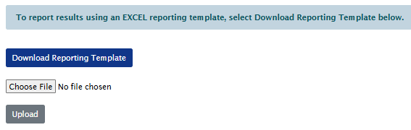
- Reporting Results Using EXCEL Template: There are two ways to report results using EXCEL templates. One involves downloading a template that contains all the analytes to be reported for that round. The other is to download test group specific templates and upload them separately. Previously, the layout of the download/upload views were different. The revision has standardized the layout of the view.
- Significant Figures and Decimal Places in PT Reports: Previously, the excel reports and/or the pdf reports was not consistent in how numbers were displayed for things like RDL, SDPTA, and N. These are now standardized.
- Format of Assigned Value for non-spiked aroclors: For samples that are not spiked for a specific aroclor, the assigned value is a threshold value that is 15% of the concentration of the aroclor that the sample is spiked with. This display caused some confusion with customers as to how they were being evaluated. The threshold values are now appended with a “<” sign (e.g., <1.23).

2.2 Access Historic PT Reports
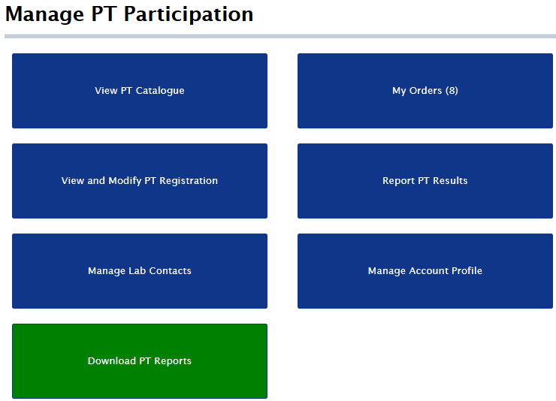
PTC customers can now access PT reports from previous PT rounds. When the Download PT Reports tile is selected, a grid will appear that contains a list of the PT rounds for which PT reports can be downloaded.

2.3 Download PDF of Reported Results
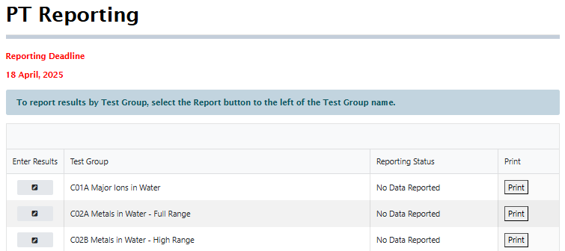
When the Portal was introduced, customers requested the ability to download a pdf of the results that they reported. This would provide them with a record of what was reported in case there was ever a discrepancy between what was reported and what appeared in the preliminary report. On the PT Reporting page for the PT round, a Print button was added for each registered test group. Selecting this will download a dated pdf record of the reported results for that test group.

2.4 Trend Analysis
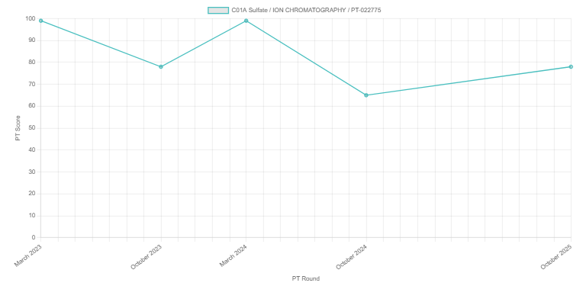
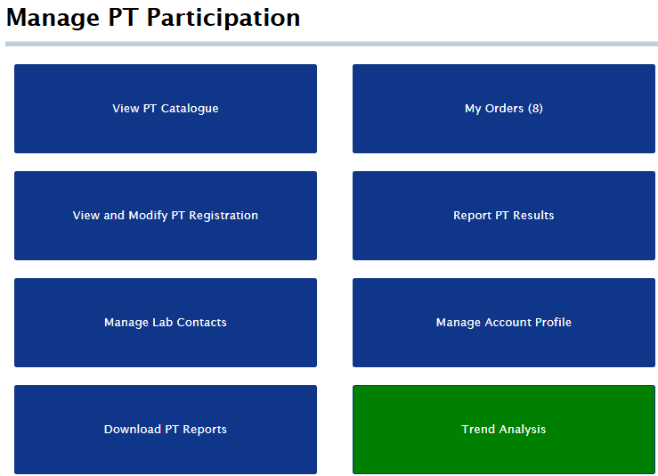
Customers are now able to view trend plots of PT scores for any analyte for which they are registered. There is a new tile on the main page labeled “Trend Analysis.” When selected, the customer can proceed to selecting a registered analyte to display a trend plot of PT scores.

2.5 Bulk Deletions
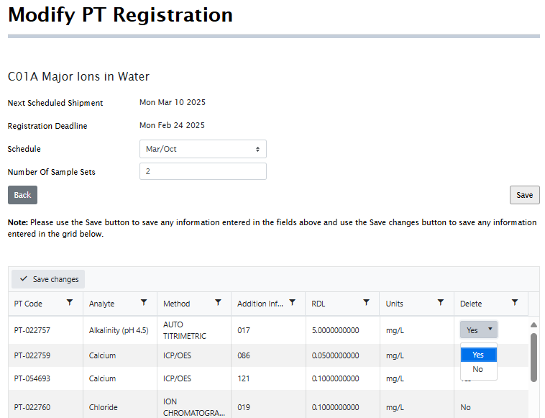
From the Modify PT Registration view of the registered test group, a customer can select multiple rows to delete. Once the Save Changes button is selected the flagged analytes will be removed from the current registration.

2.6 Additional Way to Add New PT Registrations
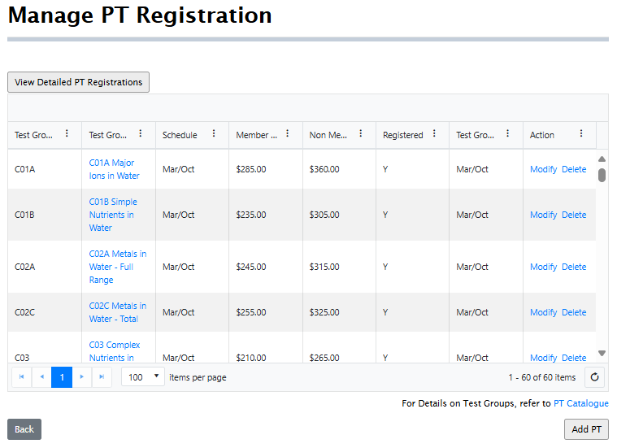
Previously, the only way to register for new PT was to select the Add PT button located below the Manage PT Registration Grid.
Customers can now add PT by selecting the Test Group link located in the second column and then selecting the Add PT button located below the displayed grid. This will open a blank test group registration view that can be used to add analytes to the cart, and subsequently submitted for Checkout.

2.7 Amended Invoice Attachment to Email
When customers make changes to their PT registration after the orders were changed for a round, the order and invoice was modified accordingly and made available for payment in the Portal. An email notification is now sent that contains the amended invoice as an attachment.

